PREVALENCE OF DEPRESSION AND POST TRAUMATIC STRESS DISORDER AMONG ADOLESCENTS WITH HIV/AIDS ATTENDING COMPREHENSIVE CARE CLINICS IN PUBLIC HOSPITALS IN RUIRU SUB COUNTY

DR. WARIIMI KARINGI
H118/42195/2022

PROPOSAL SUBMITTED FOR EXAMINATION IN PARTIAL FULFILLMENT OF THE REQUIREMENTS FOR AWARD OF THE FELLOWSHIP IN EPIDEMIOLOGY AND BIOSTATISTICS OF THE UNIVERSITY OF NAIROBI

2024

STUDENT’S DECLARATION

I certify that this dissertation proposal is my original work and has not been presented anywhere else in any other university.

DR. WARIIMI KARINGI
H118/42195/2022
Department of Paediatrics and Child Health

Signed:…… … Date:……29/11/24…………….

SUPERVISORS’ APPROVAL
Prof. Ruth Nduati
Department of Child Health and Pediatrics

Signed:…………………………………. Date:………………………………….

Prof Muthoni Mathai
University of Nairobi

Signed:…………………………………. Date:………………………………….

Dr. Cyrus Mugo
Kenyatta National Hospital

Signed:…………………………………. Date:………………………………….

DEDICATION
I dedicate this study to adolescents living with HIV and handling depression and PTSD concurrently.

ABBREVIATIONS AND ACRONYMS
AIDS Acquired Immunodeficiency Syndrome
ALHIV adolescents living with HIV
ART antiretroviral therapy
CCC Comprehensive care clinics
HAART highly active antiretroviral therapy
HIV Human Immunodeficiency Virus
MHD Mental health disorders
PTSD post traumatic stress disorder

OPERATIONAL DEFINITION OF TERMS
Acquired Immunodeficiency Syndrome(AIDS) refers to progressed HIV.
Adherence – considered to be adherent by answering no to any of the questions: do you ever miss the medicines you are supposed to take? ; do you ever refuse to take the medicines you are supposed to take? ; do you ever not take the medicines because you do not want to take them in front of other people? ; do you ever have problems taking the medicines because you do not know why you are taking them? ; do you ever have problems taking the medicines on time or taking them every day?
Adolescent- child aged between 10 and 19 years.
Disclosure- considered disclosed to by answering correctly to either of these questions: why do you come for visits at this clinic? ; do you know what your illness is called? ; why do you have to take medicines?
Human Immunodeficiency Virus(HIV) - a viral infection that is transmitted through body fluids and is chronic in nature. It is defined as having one positive HIV DNA PCR test or one positive HIV ELISA antibody test.
Mental Health Disorder (MHD) – conditions including depression, post-traumatic stress disorder (PTSD),generalized anxiety disorder (GAD), panic disorder, phobias, social anxiety disorder and obsessive-compulsive disorder (OCD).

ABSTRACT
Background: The incidence of mental health disorders(MHD’s) among adolescents has been on a steady rise, with depression, anxiety disorders and post-traumatic stress disorder being reported as the most common. The exact incidence of MHDs among adolescents who have HIV/AIDS is unknown in our local set up. MHDs have been reported to have a negative impact on the overall care that is given to adolescents living with HIV(ALHIV) by reducing adherence to medication leading to increase in the viral load. Goals and objectives: We aim to determine the psychosocial wellbeing and prevalence of depression and PTSD among adolescents with HIV/AIDs attending comprehensive care clinics in public hospitals within Ruiru Sub county by using standard tools to screen those that are at risk as well as identify the factors associated with depression and PTSD and their effects on viral suppression and retention in care.
Methods: We propose to carry out a cross sectional descriptive study in various health facilities within Ruiru Subcounty that have comprehensive care clinics that attend to adolescents with HIV/AIDS aged between 10 and 19 years. An interviewer administered questionnaire will be administered by the principal investigator and research assistant. The HEEADSS questionnaire will be used to determine the psychosocial wellbeing, depression will be assessed using the Patient Health Questionnaire(PHQ-A) tool while Post Traumatic Stress Disorder will be screened using the Child and Adolescent Trauma Screen( CATS) for those below 18 and PTSD Checklist for DSM-5 (PCL-5)tool for those above 18 years. Data will be analyzed using R software version 4.1.3. Descriptive statistics will be computed .Continuous data will be presented using medians and interquartile ranges (IQR) while categorical data will use frequencies and percentages. Univariate and multivariate linear regression analysis will be applied to determine the factors associated with depression and PTSD. Chi square statistics and binary logistic regression will be used to determine whether there is an association between the dependent and independent variables.
Expected result: We hypothesize that the standard tools when applied to the adolescents will be able describe the psychosocial wellbeing and to identify the ALHIV who are at risk for depression and PTSD.

TABLE OF CONTENTS
STUDENT’S DECLARATION ii
DEDICATION iii
ABBREVIATIONS AND ACRONYMS iv
OPERATIONAL DEFINITION OF TERMS v
ABSTRACT…………………………………………………………………………..vi
TABLE OF CONTENTS vii
CHAPTER ONE: INTRODUCTION 1
1.1: Background of the study 1
1.2: Problem Statement 2
1.3 Justification 3
1.4 Research Question 4
1.4.1 Study Objectives 4
CHAPTER TWO: LITERATURE REVIEW 5
2.1 Neurocognitive development in adolescents and the impact of HIV on the pace of neurocognitive development 5
2.2 Triggers of Mental Health Disorders 6
2.2.1 Chronic medical conditions 6
2.2.1.1 HIV/AIDS 7
2.2.2 Other triggers of Mental Health Disorders 8
2.3 Depression and PTSD in adolescents 9
2.3.1 Depression and PTSD among adolescents with HIV/AIDS 11
2.4 Measurement of mental health status in adolescents 14
2.4.1 Tool that integrates clinical and mental health assessment – HEEADSSS tool 14
2.4.2 Tool for screening for depression – PHQ-9 14
2.4.3 Tool for screening for PTSD – Primary Care PTSD Screen for DSM-5 (PC-PTSD-5) 14
2.5 Measurement of Viral Load and Drug Adherence in HIV 15
CHAPTER THREE: METHODOLOGY 16
3.1 Study Design 16
3.2 Study Area/ Setting 16
3.3 Study Site 16
3.4 Study Population 17
3.4.1 Inclusion Criteria 17
3.5 Study Period 17
3.6 Definitions of key exposures and outcomes 17
3.6.1 Dependent Variable 17
3.6.2 Independent Variable 17
3.7 Sample size calculation 17
3.8 Data collection tools 17
3.8.1 HEEADSS Questionnaire………………………………………….………17
3.8.2 Patient Health Questionnaire -9 18
3.8.3 Primary Care PTSD Screen for DSM-5 (PC-PTSD-5) 19
3.9 Data collection procedure 19
Patient Recruitment Procedure 19
Data Collection 20
3.10 Data management 21
3.10.1 Data Cleaning 21
3.10.2 Data Analysis 21
3.11 Ethical considerations 21
3.12 Study strengths and limitations 22
3.12.1 Strengths 22
3.12.2 Limitations 22
3.13 Study Timelines 22
REFERENCES 23
APPENDICES 31
Appendix 1: MODIFIED HEEADSSS QUESTIONNAIRE 31
Appendix 2: PATIENT HEALTH QUESTIONNAIRE-9 39
Appendix 3: Primary Care PTSD Screen for DSM-5 (PC-PTSD-5) 41
Appendix 4: ASSENT FORM FOR MINORS 44
Appendix 5: INFORMED CONSENT FORM 46
Appendix 6: INFORMED CONSENT FORM FOR PARENTS OF MINORS 48

CHAPTER ONE: INTRODUCTION

1.1: Background of the study
Advancements in medical care, especially the availability of highly active antiretroviral therapy(HAART), have prolonged the survival of children who have acquired HIV either vertically or horizontally and reduced the morbidity and mortality associated with HIV/AIDS by improved immune function and suppression of HIV viral load(1). These adolescents need follow up at comprehensive care clinics (CCC) which ensure that compliance to medication is adhered to and any adverse effects are monitored and treated where necessary in order to enhance retention in care.
Globally adolescents are about a sixth of the world’s population, roughly 1.2 billion (2). They make up about 23% of sub- Saharan Africa’s population and are about 24% of Kenya’s population by age (3) (4). Globally in the year 2022,adolescents living with HIV were about 1.65 million ,majority of whom are found in sub-Saharan Africa.
Adolescence is an intermediate phase that prepares children for adulthood and involves changes that are either intellectual, cognitive, physical and psychological in the adolescent.
Worldwide, one in seven adolescents experiences a mental health disorder with depression, anxiety and behavioral disorders being among the leading causes of morbidity in this age group. Most adolescents who attempt suicide have at least 1 mental illness.
Mental Health Disorders(MHDs) are defined as conditions that affect the thinking, mood, behaviour and feelings causing significant impairment of personal functioning. They can occur as single episodes, persistent or can be relapsing. Majority are diagnosed by mental health professionals. MHD’s that are not treated have been linked to low adherence to HAART and many cases of loss to follow up.
Depression is a mood disorder that causes persistent feelings of sadness and loss of interest in daily activities. Some adolescents who have depression may attempt self-harm behaviour including suicide, others feel hopeless or exhibit a change in their usual activity levels.

Posttraumatic stress disorder (PTSD) is a psychiatric disorder that may occur in people who have experienced or witnessed a traumatic event, series of events or set of circumstances. It is associated with functional and cognitive impairment (5).
The stressful event may be emotionally or physically harmful or life-threatening to the individual and may interfere with the whole being of the individual cutting across their social, physical, spiritual and mental aspects.
HIV is transmitted through vertical or horizontal routes. Vertical transmission involves passage of the virus from the mother who is infected with HIV to the child during pregnancy, child birth or through breastmilk.
Horizontal transmission occurs through two modes: sexual and non-sexual/parenteral. Sexual route involves ranges from sexual exploitation, sex without barrier contraceptives like condoms and early coerced sex. Parenteral route involves sharing needles for intravenous drug users, unsafe medical practices – unscreened blood products and traditional practices like female genital mutilation and scarification with shared blades.
HIV can be confirmed in the body through three different test: antibody tests, antigen/antibody tests and nucleic acid tests. Antibody tests include most rapid tests that can be performed on blood or oral fluid. Antigen/antibody tests are used in laboratories while nucleic acid tests are used as confirmatory tests where antibody tests are negative or in instances where there has been a recent exposure to possible HIV. (6).
HIV/AIDS may at times present with MHDs. Some of the HAART can also cause MHDs in those who are taking them. These two factors among others have been found to make the adolescent with HIV/AIDS more likely to have mental health disorders compared to the adolescent without HIV (9).

1.2: Problem Statement
Mental health disorders account for a significant portion of disability due to non- communicable diseases and have been noted to be a leading cause of health burden among adolescents (7). Globally, depression is estimated to occur among 1.1% of adolescents aged 10–14 years, and 2.8% of 15–19-year-olds. In sub-Saharan Africa, there are high rates of reported depression and anxiety at 26.9% and 29.8% respectively among the general population of adolescents.
Adolescents are vulnerable to mental health disorders due to their psychological development that affects their ability to make safe decisions coupled with risk factors that contribute to stress during adolescence (8). In Kenya, research has shown that adolescents have the poorest outcome – viral suppression and poor retention in care – among all the age groups of people living with HIV/AIDS (10) .
A study done in Kenya focusing on adolescents reported the prevalence of depression to be 44% which is a significant percentage that shows a large unmet need for mental health services. The exact prevalence of mental health disorders among adolescents with HIV/AIDS is unknown because screening for mental health disorders is not routinely done in most comprehensive care clinics in Kenya and due to stigma, that accompanies those having HIV and/or mental health disorders.
Knowing the psychosocial wellbeing and prevalence of depression and PTSD among AHIV by using standardized tools will demonstrate the burden of the two diseases and the impact they have on key aspects of HIV care: retention in care and viral suppression. It will also help identify the programs and challenges or gaps that exist in the management of MHD among adolescents. Any adolescents who may be found to be at risk for MHD’s will be referred to mental health practitioners for follow up.

1.3 Justification
The prevalence of mental health disorders(MHDs) among them depression is gradually increasing among adolescents more so those living with HIV.
This study is unique in the following ways: It is set up in a region with a relatively low prevalence of HIV and in a rural/peri-urban population region. It will facilitate the determination of whether or not there is co-existence of depression and PTSD using standardized tools that will be applied concurrently. The study will also link the mental health status to key indicators of quality HIV care specifically viral suppression and retention in care.
Demonstrating the true magnitude of depression among ALHIV knowing the effects it has on the quality of life and management of HIV, if left untreated ,will help focus attention on the need for early screening and initiation of the appropriate treatment modalities with aiming to reduce suffering with the accompanying negative outcomes.
It will be keeping in line with the Kenya Mental Health Policy(2015-2030) and also will provide good evidence that can be presented to policy makers and governments in order to drum up support for mental health programs, increase social awareness about mental health conditions identification and treatment all in efforts to reduce stigma and improve the quality of life.
The mental health awareness programs can stretch to include schools and religious institutions as places where more identification can be done.

1.4 Research Question
1. Using standardized tools, what is the psychosocial wellbeing and prevalence of depression and PTSD among adolescents with HIV/AIDs attending comprehensive care clinics in hospitals within Ruiru Sub county?

2. What are the factors associated with depression and PTSD among adolescents with HIV/AIDS attending CCC in hospitals in Ruiru subcounty?

3. What is the association between the psychosocial and demographic factors and adolescents’ mental health on viral suppression and adherence to care?

4. What are the mental health services available for mental health services available for adolescents with HIV having depression and PTSD attending CCC in hospitals in Ruiru Subcounty?

1.4.1 Study Objectives

1.4.1.1Broad Objective
- Using standardized tools to describe the psychosocial well-being and to determine the prevalence of depression and PTSD among adolescents with HIV/AIDS attending CCC in public hospitals in Ruiru subcounty.

1.4.1.2 Specific Objectives

- Identify the factors associated with depression & PTSD among adolescents with HIV/AIDS attending CCC in public hospitals in Ruiru subcounty.
- Describe the association between the psychosocial wellbeing and adolescents’ mental health (depression and PTSD) on viral suppression and adherence to care.
- Describe mental health services available for adolescents with HIV having depression and PTSD attending CCC in public hospitals in Ruiru Subcounty.

CHAPTER TWO: LITERATURE REVIEW

2.1 Neurocognitive development in adolescents and the impact of HIV on the pace of neurocognitive development
Adolescence is a phase that helps transition children to adulthood and involves significant changes that occur in the adolescent involving their social, emotional and physical aspects accompanied by changes in language and cognitive skills. (12) Adolescence is broadly classified into three stages based on the age: early (10-13 years) ,middle (14-16 years) and late adolescence (17 – 20 years and beyond),each characterized by a set of distinct psychologic, social and biologic issues.
Early adolescence is characterized by the onset of puberty associated with rapid somatic changes coupled with the need for the adolescent to be independent. Peer relationships are established with preference towards same-sex groups.
Middle adolescence is associated with increased experimentation/risk-taking behavior. Cognitive abstract thought processes set in with the adolescent becoming more concerned with attractiveness and increased introspection. The relationship with the family is marked by the struggle between autonomy and dependence on parents.
Late adolescence involves the final stages of somatic development with consolidation of their sexual identity. Cognition becomes less self-centered with increase towards idealist and absolute thought processes. Practical independence sets in with the family becoming the secure base. Intimate relationships form at this time and career decisions get firmed up as well .
The timings of onset of puberty and setting into the adult role vary based on the cultural set up hence broadening the age group from 10 to 24 years. (13)
The human brain undergoes functional and structural reorganization during adolescence. It is highly plastic allowing the environment to dictate its development allowing both emotional and intellectual aspects as well as harmful influences(14).
The developing brain of the adolescent may adapt differently to stressors such as impoverished living conditions, exposure to violence and abuse as well as a higher prevalence of chronic conditions and challenges in accessing quality care for the stressors predisposing the adolescent to mental health disorders(MHDs).
The ability to make sound decisions in adolescence is hampered due to the relative immaturity of the neurocircuitry in the ventral regions of the prefrontal cortex. This coupled with the increase in novelty/sensation-seeking tendency together with the thrill of adolescents to engage in risky behavior, make the more likely to make rash decisions due to poor control of inhibitions and greater impulsive behavior..(15,16)
HIV infection has been postulated to have either a direct effect on neurodevelopment during the first few years of life where rapid brain development occurs or indirectly through recurrent infections leading to poorer health.
Children and adolescents with HIV have significant deficits in cognitive domains such as simultaneous processing , language and motor skills ,executive functions and learning (17–19)compared to those without HIV(20,21). Those with advanced disease have been found to have more severe deficits. (22–24).

2.2 Triggers of Mental Health Disorders

2.2.1 Chronic medical conditions
Chronic medical conditions are defined as conditions that are present in an individual for a period longer than a year and negatively interfere with activities of daily living .
Higher rates of chronic diseases have been reported among adolescents and this is attributed to advances in pediatric medicine such as hygiene, nutrition and control of infectious diseases (25,26) leading to increased survival in non-communicable diseases that were previously fatal during childhood.
Chronic illness may delay physical growth due to deficiency of nutrients through poor intake and poor absorption due to chronic inflammation and infection; increased metabolic needs due to excess physiological work, toxin excess due to liver or kidney injury, interference with the control hypothalamic hormones from chronic inflammation, stress which leads to reduction in the production of cytokines and growth hormone and the adverse effects of medications like steroids. Failure to manifest secondary sexual characteristics especially in boys has been found to result in low self-esteem. (27,28).
Chronic disease is associated with psychological problems from physical symptoms like fatigue with pain and fatigue coupled with hospital visits that interfere with activities of daily living and maintaining peer relations eventually causing frustration(25,29). The severity of the recurrent illness may interfere with regular school attendance inadvertently causing poor vocational preparation leading to loss of financial independence later on. At times the adolescent and their family are forced to choose between school and disease management (27).
Adolescents with chronic illness may feel different from the other adolescents and may be stigmatized from their peers leading to poor self-perception. (30). Chronic illness may interfere with the teen’s perception of their body bringing about insecurities and low self-esteem.
At times the adolescent may end up changing or not taking their medication without medical consent leading to poor disease control. Anger and self- pity due to having a chronic illness as well as poor judgement on how to cope with the various feelings are likely to interfere with compliance to the medication regimen.
Parents of children with chronic illnesses tend to develop inappropriate parental attitudes and behaviors, ranging from overprotection to rejection, that negatively interfere with the adolescents’ psychological well-being (31). Some parents of the adolescents do not let them act independently, interfering with their comfort. At times poor prognosis of the disease may make the adolescents feel helplessand hopeless. Some of the adverse effects from the medication cause psychological distress (32,33). Chronic stress has been linked with persistent inflammation in the body, that manifests with to poorer health outcomes(25).

2.2.1.1 HIV/AIDS
Adolescents living with with HIV include those who got vertically infected who could either be on treatment or slow progressors who are not on treatment and those who have acquired it horizontally.
Different contextual and social factors increase the vulnerability of adolescents to horizontal transmission of HIV. They include gender, age, sexual orientation, education and economic status as well as value systems about sexual activity. Adolescents who are especially vulnerable include orphans, refugees and migrants and those affected by humanitarian crises. Having HIV is a risk factor in that there may be stigmatization and a higher likelihood of being orphaned by AIDS leading them to engage in sex in order to gain economic support (34).
Pre-existing mental health disorders that are inadequately controlled are associated with increased risk of HIV due to failure of compliance with medication and increased likelihood behavioral risk factors such as unsafe sexual practices with multiple partners, intravenous drug use and sexual abuse . They may also interfere with the ability to assimilate information on HIV/AIDS such as safe sex (35,36).
HIV penetrates the central nervous system causing encephalitis which leads to loss of integrity of the blood-brain barrier. This allows cellular and non-cellular inflammatory immune components to enter resulting in damage to neurons and glial cells altering the brain structure resulting in defects in cognitive and motor development(37).
Children with HIV/AIDS often have growth suppression manifesting as delayed puberty and adrenarche attributed to growth hormone resistance and increased cortisol levels. Higher rates of mental health disorders and substance abuse are reported among the ALHIV partly attributed to disclosure and declaration of HIV status .Those who acquire HIV horizontally may be guilt ridden while those who acquire vertically may blame their parents, both cases necessitating psychosocial counseling.
Testing positive for HIV in itself has been shown to be a stressor due to the impact of the diagnosis and the subsequent effects such as a complex therapeutic regimen and shortened life expectancy as well as stigmatization, loss of social support and discrimination, that leads to stress causing changes in cognition (38). ALHIV are likely to have ill parents who require constant medical care while others are likely to be orphaned, both of which increase the likelihood of mental health problems.
Some antiretroviral drugs have been associated with changes in cognition, mood and behavior(39).

2.2.2 Other triggers of Mental Health Disorders
Adverse childhood experiences(ACEs) are defined as potentially traumatic events that occur before age 18 that are not common in normative child development and frequently overwhelm a typical child’s regular coping skills. They range from poverty, child abuse and neglect, dysfunctional family relations to pollution and These are viewed as chronic stressors that have poor effects to youth mental and physical health(25,40).
Exposure to different types of ACE’s is associated with different types of mental health disorders with those having four or more types being polytraumatized hence more likely to have poorer mental health. The probability of having PTSD has been reported to be directly proportional to the exposure to ACEs.(41).
Children who have experienced maltreatment have been found to have body changes that include , greater activation of the hypothalamic-pituitary-adrenal (HPA) axis, smaller volume of the prefrontal cortex and elevation in inflammation levels which predispose to MHDs (42,43) involving both insecure attachment and emotion dysregulation.
Some modifiable risk factors that are attributed causing depression include diet, weight and substance abuse( alcohol, tobacco and cannabis).
Substance/medication-induced mental disorders include anxiety, psychotic ,manic or depressive symptoms which manifest physiologically after the use of substances of abuse or medications and may either present during, active use, intoxication or withdrawal (44).
Many regions of the brain and neurotransmitter systems are affected by both mental illnesses and substance use specifically circuits involved in reward and executive function(45,46). Some drugs cause changes in the brain function and structure predisposing the adolescents to depression due to increase in the rewarding effects of some substances, increasing the likelihood of developing substance use disorder.
Undiagnosed or untreated mental health disorders may prompt the adolescent to self-medicate and/or self-treat with alcohol . Alcohol has neurotoxic effects on the developing brain of the adolescent. Cannabis use has been found to alter the amount of serotonin and other neurotransmitters causing increase in the depressive symptoms. Excessive weight gain can have a negative impact on the self-esteem of the adolescent increasing the risk of depression. Genetic factors with the appropriate trigger may increase the chances of depression (47)
Adolescents with MHD’s are much more likely than those without MHD’s to engage in unsafe sexual behavior due to impulsivity, self-destructive attitudes, immaturity of their cognition, increased substance use, and sequelae of sexual abuse (48)

2.3 Depression and PTSD in adolescents
Depression is described as a mental health disorder that is characterized by loss of interest in activities and a prolonged feeling of sadness that both interfere with the daily activities of an individual (49).
Globally, depression has been reported in 1.1% and 2.8% of adolescents aged 10–14 years, and 15–19-years respectively. Its estimated prevalence among adolescents in Africa is about 26.9%.
The prevalence of depression is significantly linked to age being low in children and higher in older age groups. One of the factors that is postulated to bring about increased depression with age is the set of biological and social changes occurring during puberty(47,50)
Studies have reported that generally adolescents with HIV have a higher prevalence of depression compared to those who do not have HIV(51). Globally the prevalence of depression among the adolescents with HIV has been estimated to range between 11.40 to 45.83% (52–54).
Depression not only predisposes ALHIV to suicide but also interferences with their social and educational activities. Suicide is ranked as the fourth leading cause of mortality among adolescents and youth worldwide(55).
Depression has been linked with poor academic performance in instances where it occurs in early life, more cases of unemployment and lower levels of perceived social support from the society during moments of need (56–58).
The American Association of Pediatrics recommends that all adolescent patients be screened annually for depression using a formal tool( Patient Health Questionnaire- 9) and those that score positive on the screening tool be further evaluated (59).
Treatment modalities of depression in adolescence include pharmacotherapy, psychotherapy, or both with options individualized based on the severity of the condition, the availability of the therapeutic modality, associated risk factors, the preference of the patient/family, and family support. It involves a multidisciplinary approach.
Posttraumatic stress disorder (PTSD) is a psychiatric disorder that may occur in people who have gone through a traumatic event, series of events or set of circumstances. It is associated with functional and cognitive impairment (5).
A study done in Nairobi among school going adolescents in several informal settlements reported the prevalence of depression, anxiety and PTSD to be 9.2%, 17.6% and 12.2% respectively with females who had undergone interpersonal trauma having a significantly higher incidence of all mental health outcomes than the rest of the study population (60).
Children who had experienced ACE’s were reported to have screened positive for PTSD and depression in domestic violence shelters for mothers and children (61).
PTSD is characterized using four symptom clusters: avoidance, intrusion, hyperarousal and negative alterations in cognition and mood that manifest differently. Some manifestations of PTSD in children include memories, flashbacks or nightmares after the event accompanied by physical or emotional distress. Younger children might reenact trauma during playtime. Other manifestations include disordered sleep patterns, anxiety, confusion, short temper , sudden or extreme emotional outbursts , difficulty concentrating , loss of interest in things they once loved and regression to behaviors from an earlier life stage (clinging to parents and caregivers, thumb-sucking or needing extra help with simple tasks). Teenagers are prone to risky behaviours such as self-harm and substance use (62).
The risk of a child having PTSD depends on factors such as the perceived gravity of the trauma, the rate of occurrence of the trauma and the child’s closeness to the trauma with those who have gone through the event more likely to develop PTSD compared to those who have witnessed the event .
Trauma centered - cognitive behavioural therapy is the first treatment modality of choice.

2.3.1 Depression and PTSD among adolescents with HIV/AIDS
Globally,about 1.65 million adolescents were living with HIV in 2022 of whom about 1.4 million were in sub-Saharan Africa. Adolescents constitute 4 per cent of all people living with HIV and account for 10 per cent of new adult HIV infections. (63)
The successes that have been attained with the initiation of HAART in childhood have lessened the impact of disease in childhood and improved survival into adolescence. This has inadvertently shifted focus to more issues that happen during adolescence such as mental health, chronic physical illness, injury, sexual and reproductive health (64).
Mental health disorders( MHDs) are an important yet neglected aspect of public health involving adolescents in Africa(SSA) (65). Depression is common in adolescents with HIV/AIDS yet it is easily misdiagnosed and poorly recognized in this age group (66). ALHIV who receive earlier and appropriate psychosocial support are less likely to suffer from mental health disorders compared to those who do not receive the same (67). Despite being on HAART,ALHIV have residual immune dysregulation which increases the risk for neuropsychiatric comorbidities making them 2-3 times more likely to have depression compared to the adolescents without HIV.
The presence of depression among ALHIV has been associated with some negative effects leading to the disruption of the normal chronological developmental process resulting in unwanted mental, psychological and physical consequences leading to poor health in these adolescents (68,69).
Further research has revealed that depression among ALHIV is associated with reduced quality of life, poor social support, increased levels of stigma, more cases of suicide(70) and poor coping mechanisms which lead to challenges in managing the social aspects of life(69,71–73).
Some factors associated with depression among ALHIV include gender with females being more at risk compared to males andage with older and mid- adolescents having more risk compared to early adolescents. Baseline viral load ,length of time under treatment with HAART as well as adherence, illicit drug use, education level and social support are risk factors that have been found to influence the prevalence of depression (11,34,35,74–78).
Depression in ALHIV interrupts the normal physiologic growth resulting in a wide variety of negative consequences. These include increased health care utilization and poor adherence to antiretroviral treatment leading to increased resistance to ART resulting in increased morbidity and mortality, more severe disease, lower life quality and reduced life expectancy due to untreated or partially untreated conditions(79–81) (82,83).
Other adolescents end up dropping out of school, engaging in drug abuse and engaging in high risk sexual behavior. It also leads to disruption in the adolescents’ access to livelihoods and healthcare which expose them to stigma, discrimination, suicidal behavior, isolation and sexual abuse. Overall this translates to decreased quality of life in those affected.
PTSD is one of the most extensively documented post trauma condition in individuals with HIV with higher rates of diagnosis in HIV than in other chronic illnesses. HIV is a life-threatening disorder which eventually causes progressive destruction of the immune system resulting in increased susceptibility to malignancies, there is HIV associated stigma and labelling that may be a threat to some as well as the increased likelihood of being orphaned or having a sick family member. Taking daily medications and experiencing unpleasant side effects are traumatic events associated with HIV(84).
People living with HIV are prone to more cases of PTSD than those without HIV and this is attributed to a higher likelihood of exposure to trauma in early life,eand repeat episodes of the . traumatic events. Examples of potentially traumatizing events include that physical and sexual abuse and assault and crime-related violence (85,86).
PTSD may mask other mental health disorders with high association to major depression, anxiety disorders and substance use (87).
If left untreated, PTSD results in deterioration of physical health leading to decreased quality of life. It also reduces retention in HIV care worsening immune function and increases the likelihood of reckless sexual and drug behavior which determine HIV progression (85).

2.4 Measurement of mental health status in adolescents

2.4.1 Tool that integrates clinical and mental health assessment – HEEADSSS tool
The HEEADSSS questionnaire is a tool that is used to assess the psychosocial health of adolescents and young adults. The acronym stands for the following domains - Home, Education/Employment, Eating, Activities, Drugs, Sexuality, Suicide and Safety .
The HEEADSSS screening is a widely accepted screening tool in assessing young people's (10 -25 years) psychosocial wellbeing and their risk-taking behaviors to provide appropriate interventions(88).
It is designed to start with general questions which then get more personal as the interview proceeds.
Questions to assess whether disclosure of the diagnosis and adherence to HAART have been attained(89) will be added as an addendum to the tool, specifically for this study.

2.4.2 Tool for screening for depression – PHQ-9
The PHQ-9 is a nine-item questionnaire for screening, diagnosing, monitoring and measuring the severity of depression.
It enquiries about suicidal ideation and suicide attempts as well as measures functional impairment (90).

PHQ-A is a modified version that is derived from the PHQ-9 and is designed for use in adolescents(91).

The scoring ranges from 0 – 27. The grading is based on the score with a higher score indicating a higher likelihood of depressive disorder.

2.4.3 Tools for screening for PTSD – Child and Adolescent Trauma Screen (CATS) and PTSD Checklist for DSM-5 (PCL-5)

a) Child and Adolescent Trauma Screen (CATS)
This is a tool based on DSM-5 is used as a measure of potentially traumatic events and of post-traumatic stress symptoms. It has been validated for use among adolescents in our local setting.
It was designed by Profs L. Goldbeck and L. Berliner for use in children aged 7 to 17 years. It can either be self-administered or as an interview.
The CATS tool has 15 items measuring traumatic events, 20 items measuring DSM-5 PTSD symptoms, and 5 items measuring psychosocial functioning, and can be administered in approximately 15 minutes.
Scoring involves the respondents confirming that they have experienced at least one potential traumatic event(A – criterion).Those who don’t report any traumatic event are considered to have finished the assessment.
The frequency of each symptom is graded on a 4-point scale ranging from 0-60 with a cut off of ≥ 21 being considered a clinically relevant level of symptoms.

b) PTSD Checklist for DSM 5 (PCL-5)
The Primary Care PTSD Screen for DSM-5 (PC-PTSD-5) is a 5-item tool designed for use in primary care settings to screen for individuals with probable PTSD. It is used in those more than 18 years.
It first assesses whether the respondent has been exposed to any event that may be traumatizing. event. If there is no exposure reported, the tool is complete with a score of 0.
If the respondent reports experiencing a traumatic event, they are further instructed to respond to five more yes/no questions about how the event has affected them over the past one month. A positive score is considered if 3 out of 5 items are answered “yes”.

2.5 Measurement of Viral Load and Drug Adherence in HIV
A viral load test in HIV demonstrates how much of the virus is in the body by measuring the particles of HIV in a blood sample and is regarded as the most important indicator of response to HAART . Low values show good response to treatment. Those with undetectable viral loads have been shown not to transmit the virus.
Viral load testing is done through nucleic acid test (NAT) which is carried out on a blood sample. Guidelines state that the test ought to be done at entry to care, at initiation of therapy and regularly (between 3 to 6 months) based on the various institutions.
Drug adherence to HIV refers to the process of choosing ,starting and maintaining the therapeutic drug regimen (HAART) with the goal of viral suppression and improved immune function.
There are several methods to assess drug adherence: self-report, pill count and pharmacy records. Patient self-report can either show high level or suboptimal adherence depending on the methods employed by the clinician to elicit the information.
Pharmacy records are of more use in cases where medication is obtained from one source. Pill counts are subject to alteration by patients in order to give a good impression of adherence hence may not be very reliable. Other more reliable but expensive methods of assessing adherence are the use of electronic measurement devices and therapeutic drug monitoring.
Information on viral load and drug adherence will be abstracted from the health records on the adolescents at the HIV clinics.

CHAPTER THREE: METHODOLOGY

3.1 Study Design
This will be a descriptive cross-sectional study.

3.2 Study Area/ Setting
Ruiru is a municipality and sub county in Kiambu County. It is the fourth largest urban centre in Kenya by population It is located approximately 20 kilometers by road, north east of Nairobi. It has nine elective wards.
It is an industrial town with several major factories. Most of the workers in the factories reside within Ruiru. Other people live in Ruiru and work in Nairobi and other cities. Ruiru has many residential units with coffee estates being converted into residential areas. The town has banks and shopping malls. Education facilities range from preprimary level to tertiary level with a number of public and private universities having campuses in Ruiru.
Health facilities are mostly level 3 and level 4 tier institutions in both the private and public sectors.
There is a good road network within the sub county making accessibility easy.

3.3 Study Site
The health facilities that will be visited are level 3 and 4. Level 3 hospitals have minimum members of staff that include at least one doctor, clinical officers and nurses. They offer preventive and curative services based on the local needs such as laboratory and pharmacy services and chronic disease clinics for hypertension and HIV. Cases that require advanced care are referred to higher levels of the health care system.
Level 4 facilities offer X-Ray services in addition to the care in level 3 facilities They offer surgical care as well. The director of the facility is a medic preferably a doctor by profession. Their scope of care is wider and more comprehensive involving specialist consultants.
There are 9 health facilities that offer comprehensive care clinics(CCC) with 5 catering to adolescents with HIV as well. The level 4 hospitals are Ruiru level 4 Hospital, Githurai Lang’ata Health Centre and Nazareth Ruiru Hospital while the level 3 facilities are Githunguri Health Centre and St. Joseph Wendani Hospital. The study will take place in the public facilities: Ruiru level 4 hospital, Lang’ata Health Centre and Githurai Health Centre.

3.4 Study Population

3.4.1 Inclusion Criteria
- Be diagnosed with HIV/AIDS
- Age between 10 and 19 at the time of the study
- Receive care in the facility CCC: HAART for at least 6 months

3.4.2 Exclusion Criteria
- Adolescents who are too sick to be interviewed.
- Adolescents who have not yet been disclosed to their diagnosis of HIV.

3.5 Study Period
Data will be collected between November 2024 and June 2025.

3.6 Definitions of key exposures and outcomes

3.6.1 Dependent Variable
The predictor variables will be depression and PTSD.

The moderators will be age, gender, viral load, education level, disclosure, drug use and adherence to HAART.

Adherence to HAART by the adolescents will be assessed through self-report based on a set questions in the questionnaire. Responding yes to at least 3 of the 5 questions will be considered to be adherent.

3.6.2 Independent Variable
The independent variables will be having been diagnosed with HIV.

3.7 Sample size calculation
A census study will be carried out involving all the adolescents with HIV/AIDS in all the health care facilities that have comprehensive care clinics within Ruiru subcounty.

3.8 Data collection tools
The tools that will be used are the HEEADS (Appendix 1), Patient Health Questionnaire- A (Appendix 2), Child and Adolescent Trauma Screen (CATS) (Appendix 3) and PTSD Checklist for DSM-5 (PCL-5) (Appendix 4) .

3.8.1 HEEADSSS.
The HEEADSSS is an internationally recognized tool for the assessment of the psychosocial health of adolescents and young adults. The acronym stands for the following domains - Home, Education/Employment, Eating, Activities, Drugs, Sexuality, Suicide and Safety .
It provides a structure for gradually developing rapport with a young person over a short period of time, while systematically gathering information about their life; depicting a picture of the young person’s strengths and protective factors; carrying out a risk assessment with screening for specific risk factors; identifying areas that need intervention; guiding health conversations and identifying need for intervention and referral.
It is designed to start with general questions which then get more personal as the interview proceeds.
It is used to screen the psychosocial factors of an adolescent.
It is best completed with the adolescent is alone, by the clinician. Once the assessment is completed, the findings are documented and appropriate communication given to the adolescents..

3.8.2 Patient Health Questionnaire -A
The Patient Health Questionnaire(PHQ-9) is a tool for screening, diagnosing, monitoring and measuring the severity of depression among patients.
It was developed by a team of clinicians and researchers led by Dr. Robert L. Spitzer in order to help improve the recognition of mental health disorders by primary care physicians.
The PHQ-9 Modified for Adolescents (PHQ-A) is a version that has easier questions for those below 18 years which explore several different aspects of depression and has a section that assesses the likelihood of suicidality.
The scoring ranges from 0 – 27. The grading is based on the score with higher scores being more predictive of depression.
It can either be administered by the clinician or adolescent. It takes about 5 minutes to fill out.
Interpretation of the questionnaire involves scanning it with verification of the positive responses by the clinician then application of diagnostic algorithms at the bottom of the page
Before the final diagnosis is made, the clinician will have to rule out physical causes of depression, normal bereavement and history of a manic episode.
A diagnosis of major depression is made when 5 or more of the 9 criteria have been present for at least more than half the days in the past 2 weeks and 1 of the symptoms is depressed mood or anhedonia.
The PHQ-A score of greater than 10 had a sensitivity of 88% and specificity of 88% for major depression.

3.8.3 Post Traumatic Stress Disorder Checklist for DSM-5 (PCL-5)
The Post Traumatic Stress Disorder Screen for DSM-5 (PCL-5) is a 20-item tool that corresponds to the 20 symptoms in DSM-5. It was designed by Frank Weathers et al based at the National Centre for PTSD for making a provisional diagnosis of PTSD, screening individuals for PTSD and monitoring symptom change during and after treatment. It takes about 5-10 minutes to complete.
The first criterion for PTSD is having gone through an event that is traumatic. The other features include symptoms across four clusters: intrusions (cluster B), avoidance (cluster C), negative alterations in mood or cognition (cluster D) and alterations in arousal(cluster E). The symptoms have to be present for more than a month and result in significant distress or impairment.
It assesses exposure to potential traumatic events then determines the response of the individuals to the events. If there is no exposure, the screening tool is complete with a score of 0. If there has been exposure to trauma, the respondents rate the degree to which each symptom has bothered them within at least the past month on a 5 point scale The symptom cluster severity scores can be obtained by summing the scores for the items within a given cluster: cluster B(items 1-5) cluster C (items 6-7),cluster D (items 8-14) and cluster E(items 15-20).
A provisional diagnosis of PTSD is made by treating each item rated as 2= ”Moderately” or higher as a symptom endorsed then following the DSM-5 diagnostic rule which requires at least: 1 B item,1 C item, 2 D items, 2 E items. A PCL-5 cutoff score between 31-33 is indicative of PTSD.
The respondents are then sent for further assessment by a mental health specialist.

3.9 Data collection procedure

Patient Recruitment Procedure
Patient identification and recruitment will take place at the comprehensive care clinics at the various health facilities in Ruiru Subcounty. The adolescents will be approached after their routine clinic visits at the CCC. The health records will be perused using the criteria set in the inclusion criteria in order to determine those that meet the criteria. Disclosure status of the adolescent will be confirmed from the records as well in order to avoid accidental disclosure. Once the above data is obtained, it will be taken by the PI and used to approach the adolescents.
The process of informed consent will be applied. After introducing themselves, the PI and RA will explain the purpose of the study and ask the adolescents whether they will be willing to take part in the study. The aims of the study as well as any benefits or risks to the participants will be explained in simple language that the adolescents can understand based on their age and comprehension. They will be informed that taking part in the study is voluntary and they are free to opt out at any time. Their participation or lack thereof in the study will not affect the care they will receive in any way. The adolescents will also be informed that the data collected will be deidentified so that they remain anonymous and the information gathered will remain confidential.
Once they agree to participate study, they will be requested to sign a consent form (above 18 years) or assent form(below 18 years). Once the assent forms are signed by the adolescents, the accompanying guardians/parents will be asked to also sign consent forms then the interview can begin. Waiver of parental consent forms will be forwarded to Ethics in order to allow the unaccompanied minors to take part in the study.
The research assistants will be 2 members of staff (nurses) from the Kiambu Level 5 Hospital comprehensive care clinic since they know what it entails to work with the adolescents. They will also be trained in good clinical practice. They will be unknown to the adolescents. The principal investigator(PI) and the research assistants (RA) will have a brief training session with a psychiatrist on how to administer and interpret the questionnaires.

Data Collection
After the study participants have signed the consent and assent forms, a pre-tested structured questionnaire will be administered by the investigator/research assistant. The interview will take place in a private consultation room, one adolescent at a time. It will take about 20 minutes to complete filling out the forms.
The questionnaire will be a combination of three tools, the modified HEEADSSS ,the PHQ-A and PCL-5 tool. The modified HEEADSSS tool gives a glimpse of the global environment of the adolescent and will also screen for adherence to medication and confirm whether disclosure has taken place. The PHQ-A questionnaire will be used to screen for depression based on the score that the respondents will get while the PCL-5 tool will be used to determine whether the adolescents have any features of PTSD. After daily completion of the questionnaires, the PI will keep them.

3.10 Data management

3.10.1 Data Cleaning
Once the data is extracted, it will be cleaned by checking for missing, erroneous data. Data will then be exported to R software version 4.1.3 for analysis.

3.10.2 Data Analysis
Data will be analyzed using R software version 4.1.3. Descriptive statistics will be computed for the study population. Continuous data will be presented using medians and interquartile ranges (IQR) while categorical data will use frequencies and percentages.
Univariate and multivariate linear regression analysis will be applied to determine the factors associated with depression and PTSD. Chi square statistics and binary logistic regression will be used to determine whether there is an association between the dependent and independent variables.

3.11 Ethical considerations
The proposal will be presented to the University of Nairobi/Kenyatta National Hospital ethical review committee in order to get approval to carry out the study. Once the approval is obtained, it will be attached to the letter that will be presented to the various hospitals where data collection will be done.
The process of informed consent will be applied. After introducing themselves, the PI and RA will explain the purpose of the study and ask the adolescents whether they will be willing to take part in the study. The aims of the study as well as any benefits or risks to the participants will be explained in simple language that the adolescents can understand based on their age and comprehension. They will be informed that taking part in the study is voluntary and they are free to opt out at any time. Their participation or lack thereof in the study will not affect the care they will receive in any way. The adolescents will also be informed that the data collected will be deidentified so that they remain anonymous and the information gathered will remain confidential.
Once they agree to take part in the study, they will be requested to sign a consent form (above 18 years) or assent form(below 18 years). Once the assent forms are signed by the adolescents, the accompanying guardians/parents will be asked to also sign consent forms then the interview can begin.
For the adolescents who are below 18 years and unaccompanied by their parents/guardians ,a waiver of parental consent will be sought from ERC.
The benefits of the study to the adolescents will be that should there be any symptoms of depression noted during the interview process, the adolescents will be referred for the appropriate care. The indirect benefit of the study is that findings will be used to raise awareness about the prevalence of depression and PTSD and therefore ensure that it is actively looked out for and those found to be at risk are given the correct care.
The risk category of this study is minimal risk. This may come about during the filling of the questionnaire leading to discomfort from recounting unpleasant happenings to the adolescent and prolonged stay in the hospital outpatient department after completing their clinic appointment. In the event that the adolescents are uncomfortable sharing details that may be traumatizing to them, they will be given the option of not recounting the episode with referral to a psychologist who will help them deal with the stressful event. In order to delay waiting time, some adolescents will be interviewed before getting to be reviewed in the clinic.
The same recruitment and data collection procedure will be applied to all adolescents.
Confidentiality: The information that will be obtained will be deidentified in order to maintain anonymity with each participant having a unique study number only known to the PI. The information collected will only be available to the PI . The questionnaires will be stored in a locker that has a key, in the office of the PI. Soft copy information will be stored in the PI’s password protected computer and on the cloud. Any access to the information will be on need to know basis. The principles of data minimization will be applied. After the study period is over, the information collected will be disposed of based on the retention and deletion policies of the university mostly involving secure methods: shredding and erasing.

3.12 Study strengths and limitations

3.12.1 Strengths
The strengths of the study will be that the information gathered will be able to emphasize the burden of depression and PTSD among ALHIV hence project the need for inclusion of screening for mental health disorders in routine care as well as show the need for treatment.

3.12.2 Limitations
Most of the information will be generated on basis of self-reported information from the respondents hence the authenticity of the details may not be adequately confirmed.
In order to ensure that authenticity is attained, the participants will be reminded that the forms are anonymized so no information is traced back to any respondent.

3.13 Study Timelines

Activity | September 2023- June 2024 | July2024- September 2024 | October 2024 – November 2024 | December 2024
Proposal writing and presentation to the department
Presentation to Ethics Committee
Data collection
Data analysis
Results write up and presentation to the department

BUDGET
Item | Quantity | Unit cost (Kshs) | Total cost (Kshs)
Statistician:  - Guide data retrieving, checking and cleaning  - Data export to excel  - Data export from excel to R software version 4.1.3 for analysis.  - Data analysis, interpretation, presentation of tables and figure  - Power point guidance | 1 | 170,000 | 170,000
Printing of and photocopy of proposal, 1st draft | 6 copies | 900 | 4500
Spiral binding of 1st draft proposal to ERC and supervisors | 6 copies | 100 | 600
Printing of and photocopy of proposal, 2nd draft to ERC and supervisors | 1 copy of 60 pages | 900 | 4500
Spiral binding of 2nd draft proposal to ERC and supervisors | 6 copies | 100 | 600
Printing and photocopy of proposal, 2nd draft for ERC after corrections | 1 copy of 60 pages | 900 | 4500
Spiral binding of 2nd draft proposal to ERC and supervisors after corrections | 6 copies | 100 | 600
Printing and photocopying of results 1st draft | 5 copies 100 pages | 600 | 2500
Spiral binding of 1st draft of results to supervisors and department | 5 copies | 100 | 500
Printing and photocopying of results 2nd draft | 5 copies 100 pages | 600 | 2500
Spiral binding of 2nd draft of results to supervisors and department | 5 copies | 100 | 500
Printing and photocopying of results 3rd draft | 5 copies 100 pages | 600 | 2500
Spiral binding of 3rd draft of results to supervisors and department | 5 copies | 100 | 500
Final binding of dissertation | 15 copies | 1500 | 22500
Principal Investigator Communication | 1 | 25000 | 25000
Research Assistant | 3 | 20000 | 60,000
Ethic committee review’s fee |  | 2,000 | 3,000
Contingency |  | 45,000 | 42,500
TOTAL |  |  | 350,000

REFERENCES

1. Hoffmann C, Tabrizian S, Wolf E, Eggers C, Stoehr A, Plettenberg A, et al. Survival of AIDS patients with primary central nervous system lymphoma is dramatically improved by HAART-induced immune recovery: AIDS. 2001 Nov;15(16):2119–27.
2. World AIDS Day 2023 – events in Geneva and around the world [Internet]. [cited 2024 Feb 6]. Available from: https://www.who.int/news-room/events/detail/2023/12/01/default-calendar/world-aids-day-2023-events-in-geneva-and-around-the-world
3. Amy Roeder. Identifying unmet health needs for adolescents in sub-Saharan Africa [Internet]. Harvard School of Public Health; 2020. Available from: https://www.hsph.harvard.edu/news/features/adolescents-africa-health/
4. Kenya Demographic and Health Survey 2022. Key Indicators Report. [Internet]. Nairobi, Kenya, and Rockville, Maryland, USA: KNBS and ICF.; 2022. Available from: https://dhsprogram.com/pubs/pdf/PR143/PR143.pdf
5. Mann SK, Marwaha R. Posttraumatic Stress Disorder. In: StatPearls [Internet]. Treasure Island (FL): StatPearls Publishing; 2024 [cited 2024 Apr 25]. Available from: http://www.ncbi.nlm.nih.gov/books/NBK559129/
6. HIV Testing | HIV/AIDS | CDC [Internet]. 2022 [cited 2024 Feb 6]. Available from: https://www.cdc.gov/hiv/testing/index.html
7. Kenya Adolescent Mental Health Group. Burden and risk factors of mental and substance use disorders among adolescents and young adults in Kenya: results from the Global Burden of Disease Study 2019. EClinicalMedicine. 2024 Jan;67:102328.
8. Farley HR. Assessing mental health in vulnerable adolescents. Nursing2024. 2020 Oct;50(10):48.
9. Di Gennaro F, Marotta C, Saracino A, Occa E, Putoto G. Mental health needs of adolescents with HIV in Africa. Lancet HIV. 2022 Jun;9(6):e376.
10. Mburugu P, Muiruri P, Opiyo N, Simba J, Adunda J, Kawira R, et al. Antiretroviral therapy outcomes among adolescents and young adults in a Tertiary hospital in Kenya. Afr Health Sci. 2021 May;21(Suppl):1–7.
11. Kemigisha E, Zanoni B, Bruce K, Menjivar R, Kadengye D, Atwine D, et al. Prevalence of depressive symptoms and associated factors among adolescents living with HIV/AIDS in South Western Uganda. AIDS Care. 2019 Oct;31(10):1297–303.
12. Ciccia AH, Meulenbroek P, Turkstra LS. Adolescent Brain and Cognitive Developments: Implications for Clinical Assessment in Traumatic Brain Injury. Top Lang Disord. 2009;29(3):249–65.
13. Pozuelo JR, Kilford EJ. Adolescent Health Series: Adolescent neurocognitive development in Western and Sub‐Saharan African contexts. Trop Med Int Health. 2021 Nov;26(11):1333–44.
14. Konrad K, Firk C, Uhlhaas PJ. Brain development during adolescence: neuroscientific insights into this developmental period. Dtsch Arzteblatt Int. 2013 Jun;110(25):425–31.
15. Leather NC. Risk-taking behaviour in adolescence: a literature review. J Child Health Care. 2009 Sep;13(3):295–304.
16. Cauffman E, Shulman EP, Steinberg L, Claus E, Banich MT, Graham S, et al. Age differences in affective decision making as indexed by performance on the Iowa Gambling Task. Dev Psychol. 2010 Jan;46(1):193–207.
17. Boivin MJ, Ruel TD, Boal HE, Bangirana P, Cao H, Eller LA, et al. HIV-subtype A is associated with poorer neuropsychological performance compared with subtype D in antiretroviral therapy-naive Ugandan children. AIDS. 2010 May 15;24(8):1163–70.
18. Boyede GO, Lesi FEA, Ezeaka CV, Umeh CS. The Neurocognitive Assessment of HIV-Infected School-Aged Nigerian Children. World J AIDS. 2013;03(02):124–30.
19. Ravindran OS, Rani MP, Priya G. Cognitive Deficits in HIV Infected Children. Indian J Psychol Med. 2014 Jul;36(3):255–9.
20. Van Den Hof M, Ter Haar AM, Scherpbier HJ, Van Der Lee JH, Reiss P, Wit FWNM, et al. Neurocognitive Development in Perinatally Human Immunodeficiency Virus–infected Adolescents on Long-term Treatment, Compared to Healthy Matched Controls: A Longitudinal Study. Clin Infect Dis. 2019 May 18;ciz386.
21. Van Genderen JG, Chia C, Van Den Hof M, Mutsaerts HJMM, Reneman L, Pajkrt D, et al. Brain Differences in Adolescents Living With Perinatally Acquired HIV Compared With Adoption Status Matched Controls: A Cross-sectional Study. Neurology [Internet]. 2022 Oct 11 [cited 2024 Mar 18];99(15). Available from: https://www.neurology.org/doi/10.1212/WNL.0000000000200946
22. Ruel TD, Boivin MJ, Boal HE, Bangirana P, Charlebois E, Havlir DV, et al. Neurocognitive and Motor Deficits in HIV-Infected Ugandan Children With High CD4 Cell Counts. Clin Infect Dis. 2012 Apr 1;54(7):1001–9.
23. Jeremy RJ, Kim S, Nozyce M, Nachman S, McIntosh K, Pelton SI, et al. Neuropsychological functioning and viral load in stable antiretroviral therapy-experienced HIV-infected children. Pediatrics. 2005 Feb;115(2):380–7.
24. Laughton B, Cornell M, Boivin M, Van Rie A. Neurodevelopment in perinatally HIV‐infected children: a concern for adolescence. J Int AIDS Soc. 2013 Jan;16(1):18603.
25. Russo K. Assessment and Treatment of Adolescents With Chronic Medical Conditions. J Health Serv Psychol. 2022 May;48(2):69–78.
26. Suryavanshi MS, Yang Y. Clinical and Economic Burden of Mental Disorders Among Children With Chronic Physical Conditions, United States, 2008–2013. Prev Chronic Dis. 2016 May 26;13:150535.
27. Michaud PA, Suris JC, Viner R. The adolescent with a chronic condition : epidemiology, developmental issues and health care provision / P-A. Michaud, J. Suris and R. Viner. 2007;44.
28. Yeo M, Sawyer S. Chronic illness and disability. BMJ. 2005 Mar 26;330(7493):721–3.
29. Suris JC, Michaud PA, Viner R. The adolescent with a chronic condition. Part I: developmental issues. Arch Dis Child. 2004 Oct 1;89(10):938–42.
30. Sandstrom MJ. Brief Report: Peer Rejection, Social Behavior, and Psychological Adjustment in Children with Juvenile Rheumatic Disease. J Pediatr Psychol. 2004 Jan 1;29(1):29–34.
31. Holmbeck GN, Johnson SZ, Wills KE, McKernon W, Rose B, Erklin S, et al. Observed and perceived parental overprotection in relation to psychosocial adjustment in preadolescents with a physical disability: The mediational role of behavioral autonomy. J Consult Clin Psychol. 2002;70(1):96–110.
32. Miller JM, Kustra RP, Vuong A, Hammer AE, Messenheimer JA. Depressive Symptoms in Epilepsy: Prevalence, Impact, Aetiology, Biological Correlates and Effect of Treatment with Antiepileptic Drugs. Drugs. 2008;68(11):1493–509.
33. Berkelbach Van Der Sprenkel EE, Nijhof SL, Dalmeijer GW, Onland-Moret NC, De Roos SA, Lesscher HMB, et al. Psychosocial functioning in adolescents growing up with chronic disease: The Dutch HBSC study. Eur J Pediatr. 2022 Feb;181(2):763–73.
34. HIV and Adolescents: Guidance for HIV Testing and Counselling and Care for Adolescents Living with HIV: Recommendations for a Public Health Approach and Considerations for Policy-Makers and Managers [Internet]. Geneva: World Health Organization; 2013 [cited 2024 Feb 6]. (WHO Guidelines Approved by the Guidelines Review Committee). Available from: http://www.ncbi.nlm.nih.gov/books/NBK217962/
35. Deshmukh NN, Borkar AM, Deshmukh JS. Depression and its associated factors among people living with HIV/AIDS: Can it affect their quality of life? J Fam Med Prim Care. 2017;6(3):549–53.
36. Haas AD, Lienhard R, Didden C, Cornell M, Folb N, Boshomane TMG, et al. Mental Health, ART Adherence, and Viral Suppression Among Adolescents and Adults Living with HIV in South Africa: A Cohort Study. AIDS Behav. 2023 Jun;27(6):1849–61.
37. Willis N, Mavhu W, Wogrin C, Mutsinze A, Kagee A. Understanding the experience and manifestation of depression in adolescents living with HIV in Harare, Zimbabwe. PloS One. 2018;13(1):e0190423.
38. Lyambai K, Mwape L. Mental Health Problems Experienced by HIV Positive Adolescents; A Case of Choma District, Zambia. Open J Psychiatry. 2018;08(02):97–114.
39. Checa A, Castillo A, Camacho M, Tapia W, Hernandez I, Teran E. Depression is associated with efavirenz-containing treatments in newly antiretroviral therapy initiated HIV patients in Ecuador. AIDS Res Ther. 2020 Dec;17(1):47.
40. Bomysoad RN, Francis LA. Adverse Childhood Experiences and Mental Health Conditions Among Adolescents. J Adolesc Health Off Publ Soc Adolesc Med. 2020 Dec;67(6):868–70.
41. Brockie TN, Dana-Sacco G, Wallen GR, Wilcox HC, Campbell JC. The Relationship of Adverse Childhood Experiences to PTSD, Depression, Poly‐Drug Use and Suicide Attempt in Reservation‐Based Native American Adolescents and Young Adults. Am J Community Psychol. 2015 Jun;55(3–4):411–21.
42. Tzouvara V, Kupdere P, Wilson K, Matthews L, Simpson A, Foye U. Adverse childhood experiences, mental health, and social functioning: A scoping review of the literature. Child Abuse Negl. 2023 May;139:106092.
43. Sayed S, Iacoviello BM, Charney DS. Risk factors for the development of psychopathology following trauma. Curr Psychiatry Rep. 2015 Aug;17(8):612.
44. Revadigar N, Gupta V. Substance-Induced Mood Disorders. In: StatPearls [Internet]. Treasure Island (FL): StatPearls Publishing; 2024 [cited 2024 Mar 21]. Available from: http://www.ncbi.nlm.nih.gov/books/NBK555887/
45. Ross S, Peselow E. Co-Occurring Psychotic and Addictive Disorders: Neurobiology and Diagnosis. Clin Neuropharmacol. 2012 Sep;35(5):235–43.
46. Kelly TM, Daley DC. Integrated Treatment of Substance Use and Psychiatric Disorders. Soc Work Public Health. 2013 May;28(3–4):388–406.
47. Beirão D, Monte H, Amaral M, Longras A, Matos C, Villas-Boas F. Depression in adolescence: a review. Middle East Curr Psychiatry. 2020 Oct 2;27(1):50.
48. Institute of Medicine. Public Financing and Delivery of HIV/AIDS Care: Securing the Legacy of Ryan White [Internet]. Washington, DC: The National Academies Press; 2005. Available from: https://nap.nationalacademies.org/catalog/10995/public-financing-and-delivery-of-hivaids-care-securing-the-legacy
49. Mental health [Internet]. [cited 2024 Feb 6]. Available from: https://www.who.int/health-topics/mental-health
50. Petito A, Pop TL, Namazova-Baranova L, Mestrovic J, Nigri L, Vural M, et al. The Burden of Depression in Adolescents and the Importance of Early Recognition. J Pediatr. 2020 Mar 1;218:265-267.e1.
51. Betancourt T, Scorza P, Kanyanganzi F, Fawzi MCS, Sezibera V, Cyamatare F, et al. HIV and Child Mental Health: A Case-Control Study in Rwanda. Pediatrics. 2014 Aug 1;134(2):e464–72.
52. Abebe H, Shumet S, Nassir Z, Agidew M, Abebaw D. Prevalence of Depressive Symptoms and Associated Factors among HIV-Positive Youth Attending ART Follow-Up in Addis Ababa, Ethiopia. AIDS Res Treat. 2019 Jan 2;2019:1–7.
53. Kim MH, Mazenga AC, Yu X, Devandra A, Nguyen C, Ahmed S, et al. Factors associated with depression among adolescents living with HIV in Malawi. BMC Psychiatry. 2015 Dec;15(1):264.
54. Okawa S, Mwanza Kabaghe S, Mwiya M, Kikuchi K, Jimba M, Kankasa C, et al. Psychological well-being and adherence to antiretroviral therapy among adolescents living with HIV in Zambia. AIDS Care. 2018 May 4;30(5):634–42.
55. WHO. Adolescent Health [Internet]. World Health Organization; 2023. Available from: https://www.who.int/health-topics/adolescent-health#tab=tab_1
56. Clayborne ZM, Varin M, Colman I. Systematic Review and Meta-Analysis: Adolescent Depression and Long-Term Psychosocial Outcomes. J Am Acad Child Adolesc Psychiatry. 2019 Jan;58(1):72–9.
57. Fergusson DM, Woodward LJ. Mental Health, Educational, and Social Role Outcomes of Adolescents With Depression. Arch Gen Psychiatry. 2002 Mar 1;59(3):225.
58. Naicker K, Galambos NL, Zeng Y, Senthilselvan A, Colman I. Social, Demographic, and Health Outcomes in the 10 Years Following Adolescent Depression. J Adolesc Health. 2013 May;52(5):533–8.
59. Zuckerbrot RA, Cheung A, Jensen PS, Stein REK, Laraque D, GLAD-PC STEERING GROUP. Guidelines for Adolescent Depression in Primary Care (GLAD-PC): Part I. Practice Preparation, Identification, Assessment, and Initial Management. Pediatrics. 2018 Mar;141(3):e20174081.
60. Friedberg R, Baiocchi M, Rosenman E, Amuyunzu-Nyamongo M, Nyairo G, Sarnquist C. Mental health and gender-based violence: An exploration of depression, PTSD, and anxiety among adolescents in Kenyan informal settlements participating in an empowerment intervention. PloS One. 2023;18(3):e0281800.
61. Woollett N, Bandeira M, Hatcher A. Trauma-informed art and play therapy: Pilot study outcomes for children and mothers in domestic violence shelters in the United States and South Africa. Child Abuse Negl. 2020 Sep;107:104564.
62. Donnelly CL, Amaya-Jackson L. Post-traumatic stress disorder in children and adolescents: epidemiology, diagnosis and treatment options. Paediatr Drugs. 2002;4(3):159–70.
63. UNICEF DATA [Internet]. [cited 2024 Feb 6]. Adolescent HIV prevention. Available from: https://data.unicef.org/topic/hivaids/adolescents-young-people/
64. Folayan M, Morolake Odetoyinbo null, Brown B, Harrison A. Addressing the socio-development needs of adolescents living with HIV/AIDS in Nigeria: a call for action. Afr J Reprod Health. 2014 Sep;18(3 Spec No):93–101.
65. UNICEF DATA [Internet]. [cited 2024 Feb 6]. Adolescents Statistics. Available from: https://data.unicef.org/topic/adolescents/overview/
66. Bernaras E, Jaureguizar J, Garaigordobil M. Child and Adolescent Depression: A Review of Theories, Evaluation Instruments, Prevention Programs, and Treatments. Front Psychol. 2019 Mar 20;10:543.
67. West N, Schwartz S, Mudavanhu M, Hanrahan C, France H, Nel J, et al. Mental health in South African adolescents living with HIV. AIDS Care. 2019 Jan;31(1):117–24.
68. Andrinopoulos K, Clum G, Murphy DA, Harper G, Perez L, Xu J, et al. Health Related Quality of Life and Psychosocial Correlates among HIV-Infected Adolescent and Young Adult Women in the US. AIDS Educ Prev. 2011 Aug;23(4):367–81.
69. Larios SE, Davis JN, Gallo LC, Heinrich J, Talavera G. Concerns about stigma, social support and quality of life in low-income HIV-positive Hispanics. Ethn Dis. 2009;19(1):65–70.
70. Casale M, Boyes M, Pantelic M, Toska E, Cluver L. Suicidal thoughts and behaviour among South African adolescents living with HIV: Can social support buffer the impact of stigma? J Affect Disord. 2019 Feb;245:82–90.
71. Buseh AG, Kelber ST, Stevens PE, Park CG. Relationship of Symptoms, Perceived Health, and Stigma With Quality of Life Among Urban HIV‐Infected African American Men. Public Health Nurs. 2008 Sep;25(5):409–19.
72. Greeff M, Uys LR, Wantland D, Makoae L, Chirwa M, Dlamini P, et al. Perceived HIV stigma and life satisfaction among persons living with HIV infection in five African countries: A longitudinal study. Int J Nurs Stud. 2010 Apr;47(4):475–86.
73. Pearson CR, Micek MA, Pfeiffer J, Montoya P, Matediane E, Jonasse T, et al. One Year After ART Initiation: Psychosocial Factors Associated with Stigma Among HIV-Positive Mozambicans. AIDS Behav. 2009 Dec;13(6):1189–96.
74. RO L, Akinsulore A, OA O, OO A, SK M, AS A. Depression and its association with psychological factors among adolescents living with HIV in Southwestern Nigeria. BMC Psychiatry. 2023 Jul 24;23(1):531.
75. Girma D, Assegid S, Gezahegn Y. Depression and associated factors among HIV-positive youths attending antiretroviral therapy clinics in Jimma town, southwest Ethiopia. PloS One. 2021;16(1):e0244879.
76. Gooden TE, Gardner M, Wang J, Chandan JS, Beane A, Haniffa R, et al. The risk of mental illness in people living with HIV in the UK: a propensity score-matched cohort study. Lancet HIV. 2022 Mar 1;9(3):e172–81.
77. Zhou E, Qiao Z, Cheng Y, Zhou J, Wang W, Zhao M, et al. Factors associated with depression among HIV/AIDS children in China. Int J Ment Health Syst. 2019 Feb 20;13(1):10.
26. Kumar M, Njuguna S, Amin N, Kanana S, Tele A, Karanja M, et al. Burden and risk factors of mental and substance use disorders among adolescents and young adults in Kenya: results from the Global Burden of Disease Study 2019. eClinicalMedicine [Internet]. 2024 Jan 1;67. Available from: https://www.thelancet.com/journals/eclinm/article/PIIS2589-5370(23)00505-9/fulltext
79. Uthman OA, Magidson JF, Safren SA, Nachega JB. Depression and Adherence to Antiretroviral Therapy in Low-, Middle- and High-Income Countries: A Systematic Review and Meta-Analysis. Curr HIV/AIDS Rep. 2014 Sep;11(3):291–307.
80. Ayano G, Solomon M, Abraha M. A systematic review and meta-analysis of epidemiology of depression in people living with HIV in east Africa. BMC Psychiatry. 2018 Dec;18(1):254.
81. Oh KS, Han E. A comparison of medication adherence and viral suppression in antiretroviral treatment-naïve patients with HIV/AIDS depending on the drug formulary. Morgan E, editor. PLOS ONE. 2021 Jan 8;16(1):e0245185.
82. Pence BW, Mills JC, Bengtson AM, Gaynes BN, Breger TL, Cook RL, et al. Association of Increased Chronicity of Depression With HIV Appointment Attendance, Treatment Failure, and Mortality Among HIV-Infected Adults in the United States. JAMA Psychiatry. 2018 Apr 1;75(4):379–85.
83. Betancur MN, Lins L, Oliveira IRD, Brites C. Quality of life, anxiety and depression in patients with HIV/AIDS who present poor adherence to antiretroviral therapy: a cross-sectional study in Salvador, Brazil. Braz J Infect Dis. 2017 Sep;21(5):507–14.
84. Tang C, Goldsamt L, Meng J, Xiao X, Zhang L, Williams AB, et al. Global estimate of the prevalence of post-traumatic stress disorder among adults living with HIV: a systematic review and meta-analysis. BMJ Open. 2020 Apr 27;10(4):e032435.
85. McLean CP, Fitzgerald H. Treating Posttraumatic Stress Symptoms Among People Living with HIV: a Critical Review of Intervention Trials. Curr Psychiatry Rep. 2016 Sep;18(9):83.
86. Ashaba S, Cooper-Vince CE, Maling S, Satinsky EN, Baguma C, Akena D, et al. Childhood trauma, major depressive disorder, suicidality, and the modifying role of social support among adolescents living with HIV in rural Uganda. J Affect Disord Rep. 2021 Apr;4:100094.
87. Theuninck AC, Lake N, Gibson S. HIV-related posttraumatic stress disorder: investigating the traumatic events. AIDS Patient Care STDs. 2010 Aug;24(8):485–91.
88. Saw C, Smit A, Silva D, Bulsara MK, Nguyen ETTT. Service evaluation and retrospective audit of electronic HEEADSSS (e-HEEADSSS) screening device in paediatric inpatient service in Western Australia. Int J Adolesc Med Health. 2022 Nov 29;34(6):401–9.
89. Vreeman RC, Scanlon ML, Mwangi A, Turissini M, Ayaya SO, Tenge C, et al. A Cross-Sectional Study of Disclosure of HIV Status to Children and Adolescents in Western Kenya. Tang JW, editor. PLoS ONE. 2014 Jan 27;9(1):e86616.
90. Johnson JG, Harris ES, Spitzer RL, Williams JBW. The patient health questionnaire for adolescents: validation of an instrument for the assessment of mental disorders among adolescent primary care patients. J Adolesc Health Off Publ Soc Adolesc Med. 2002 Mar;30(3):196–204.
91. Kroenke K, Spitzer RL, Williams JB. The PHQ-9: validity of a brief depression severity measure. J Gen Intern Med. 2001 Sep;16(9):606–13.

APPENDICES

Appendix 1: MODIFIED HEEADSSS QUESTIONNAIRE
Adolescent Questionnaire
Study participant number _____________ Date_______________
Sex __________________ Age______________________
Part 1: Home

1 | What is your sex? | a) Male  b) Female  c) Other
2 | Where do you live? | - Home  - Orphanage  - Other
3 | Who do you currently live with?  Select all that apply | - Mom or mother figure  - Dad or father figure  - Siblings  - Spouse/partner  - Grandparents  - Relatives  - Other
4 | To whom can you talk at home? | - Parents  - Siblings  - Relatives  - Other
5 | Is there anyone new at home? | - Yes  - No
6 | Has someone left in the last 1 year? | - Yes  - No  - Don’t know  - No response
Part 2: Education/Employment

Now I would like to ask you about your level of education and Employment
7. | Are you currently in school? | - Yes  - No  - No response
8. | If no above, what is the reason?
9. | What is the highest level of education that you have attained? | - Never attended  - Primary  - Secondary  - Post-Primary  - Secondary / 'A' Level  - College (Middle Level)  - University  - No response
10. | Who do you talk to in school when you have a problem?
12. | Have you ever been suspended? Expelled? Have you ever considered dropping out? | - Yes  - No  - Don’t know  - No response
13. | What are your future education/employment plans/goals?
14. | Are you currently involved in any work for pay? | - Yes  - No  - No response
15. | How are you paid for this work? | - In cash  - In kind  - Not paid at all  - No response
Part 3: Eating /Exercise

16. | Are there times when you miss meals? | - Once  - Sometimes  - Severally  - Never
17. | If so, why do you miss meals?
18. | Do you go to school hungry? | - Once  - Sometimes  - Severally  - Never
19. | Do you participate in any sports or other extra-curricular activities (drama, music)? | - Once  - Sometimes  - Severally  - Never
20. | Do you regularly attend a church group, club, or other organized activity? | - Yes  - No  - Don’t know  - No response
Part 4: Drugs Use

For the next few questions we will be talking about drugs use.
21. | Do any of your friends use?  Select all that apply. | - Alcohol  - Tobacco  - Miraa/khat  - Heroin  - Cocaine  - Kuber  - Mandrax  - I don’t know  - Others: Specify_____
22. | Does anyone in your family/home use?  Select all that apply. | - Alcohol  - Tobacco  - Miraa/khat  - Heroin  - Cocaine  - Kuber  - Mandrax  - I don’t know  - Others: Specify_____
23. | Have you ever tried taking/do you take?  - Alcohol  - Tobacco  - Miraa/khat  - Heroin  - Cocaine  - Kuber  - Mandrax  - Others; | - Once Sometimes Severally Never  - Once Sometimes Severally Never  - Once Sometimes Severally Never  - Once Sometimes Severally Never  - Once Sometimes Severally Never  - Once Sometimes Severally Never  - Once Sometimes Severally Never  - Once Sometimes Severally Never
Part 5: Sexuality (12 years and above)

24. | Have you ever had sex? | - Yes  - No  - Don’t know  - No response
25. | How old were you when you first had sex?
26. | What was the main reason you had sex for the first time?
27. | Was the first person you had sex with older, younger or same age as you? | - Older than me  - Younger than me  - Same age  - Don’t Know.
28. | Have you had sex with either the following? | - Boys  - Girls  - Both
29. | What does the term ‘safe sex’ mean to you?
30 | Do you or your partner use any form of regular or emergency contraception ? | Yes. _________________________  No
31. | How often did/do you use condoms to prevent HIV or other sexually transmitted diseases? | - Always  - Sometimes  - Rarely  - Never  - No response
32. | Where do you usually obtain you condom(s) from? | - Health facility  - Friends  - Pharmacy  - Mobile clinic  - Fieldworker / CHP  - Faith‐based organization  - Church / mosque  - Non-profit organization  - Market / hawker  - Other  - Don’t know  - No response
33. | How many sexual partners have you had altogether for the past 12 months?
34. | Have you ever been pregnant or worried that you may be pregnant? (females) | - Yes  - No  - Don’t know  - No response | Females
35. | Have you ever gotten someone pregnant or worried that that might have happened? (males) | - Yes  - No  - Don’t know  - No response | Males
36. | Have you ever contracted a sexually transmitted disease (STD) or worried that you had an STD? | - Once  - Sometimes  - Severally  - Never
37. | What are the types of sexually transmitted illnesses that you know of? | - Chlamydia  - Gonorrhea  - Hepatitis B  - Herpes simplex Virus  - HIV  - Human Papilloma Virus  - Syphilis  - Trichomoniasis  - Others:
38. | What is the source of information you receive on STD and reproductive health from? | - School/teacher  - Parents/Guardians  - Friends  - Religious leaders  - Internet  - Mobile phones  - Social media sites: Facebook, Instagram, Tik tok  - Mass media: TV, Radio  - Health facilities  - Magazines/Books  - Others:___________________________
Part 6: Suicide and Depression (Include PHQ-A and PCL-5 tools here)

39. | Do you feel sad or down more than usual? | - Once  - Sometimes  - Severally  d)Never
40. | Do you find yourself crying more than usual? | - Once  - Sometimes  - Severally  - Never
42. | Does it seem that you’ve lost interest in things that you used to really enjoy? | - Once  - Sometimes  - Severally  - Never
43. | Do you find yourself spending less and less time with friends? | - Once  - Sometimes  - Severally  - Never
44. | Some people who feel really down often feel like hurting themselves or even killing themselves. Have you ever felt this way? | - Once  - Sometimes  - Severally  - Never
Part 7: Safety & Violence Experiences

45. | Is there physical violence in your home? | - Once  - Sometimes  - Severally  - Never
46. | Is there violence at your school? In your neighbourhood? Among your friends? | - Once  - Sometimes  - Severally  - Never
47. | Have you ever been physically or sexually abused? Have you ever been raped, on a date or at any other time? | - Once  - Sometimes  - Severally  - Never
48. | Did you seek help for any experiences of harm or unwanted sex? | Yes  No  No response
49. | Have you ever been picked on or bullied? Is that still a problem?  If yes: | Yes No  - Once  - Sometimes  - Severally  - Never
Part 8: Disclosure and Adherence

Now we would like to know more about your visitation to this clinic.

50. | Why do you come for visits at this clinic? | - HIV  - Other Illness  - I don’t know  - Other
51. | Do you know what your illness is called? | - HIV  - Other  - I don’t know
52. | Why do you have to take medicines? | - HIV  - Other Illness  - I don’t know  - Other
53. | Do you ever miss the medicines you are supposed to take? | - Once  - Sometimes  - Severally  - Never
54. | Do you ever refuse to take the medicines you are supposed to take? | - Once  - Sometimes  - Severally  - Never
55. | Do you ever not take the medicines because you do not want to take them in front of other people? | - Once  - Sometimes  - Severally  - Never
56. | Do you ever have problems taking the medicines because you do not know why you are taking them? | - Once  - Sometimes  - Severally  - Never
57. | Do you ever have problems taking the medicines on time or taking them every day? | - Once  - Sometimes  - Severally  - Never

Appendix 2: PATIENT HEALTH QUESTIONNAIRE-A
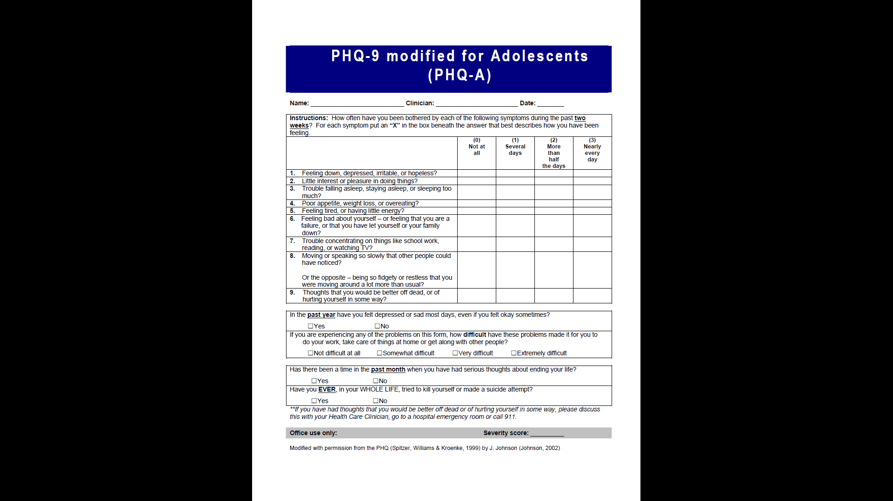

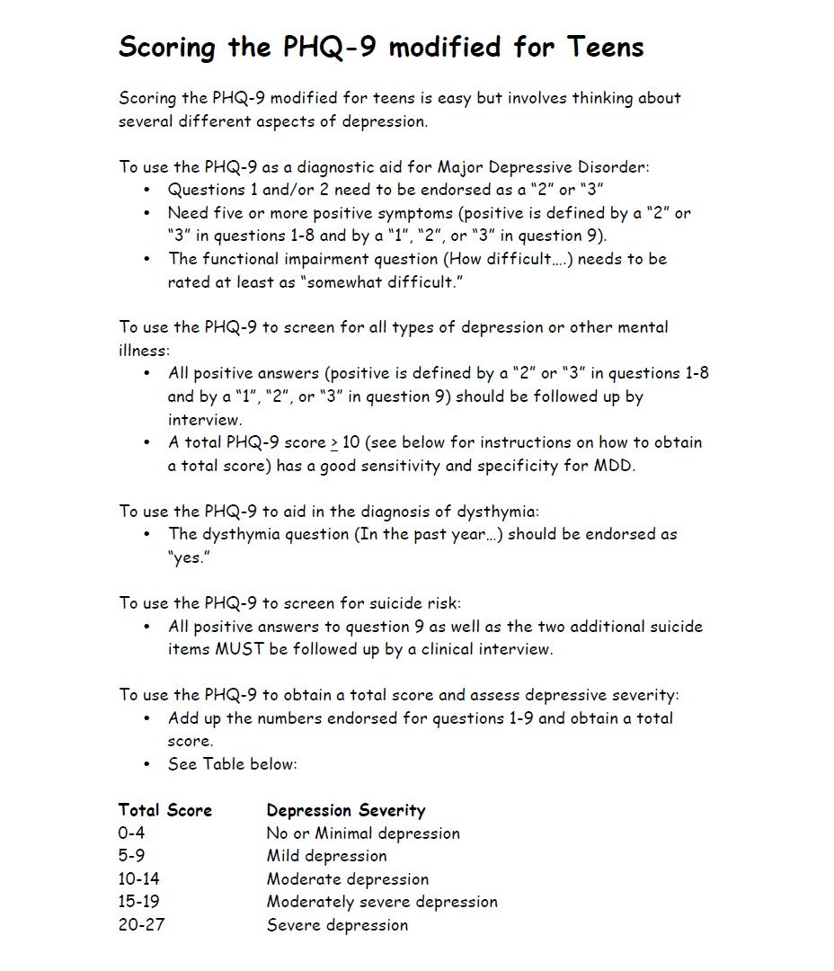

Appendix 3: Child and Adolescent Trauma Screen(CATS)
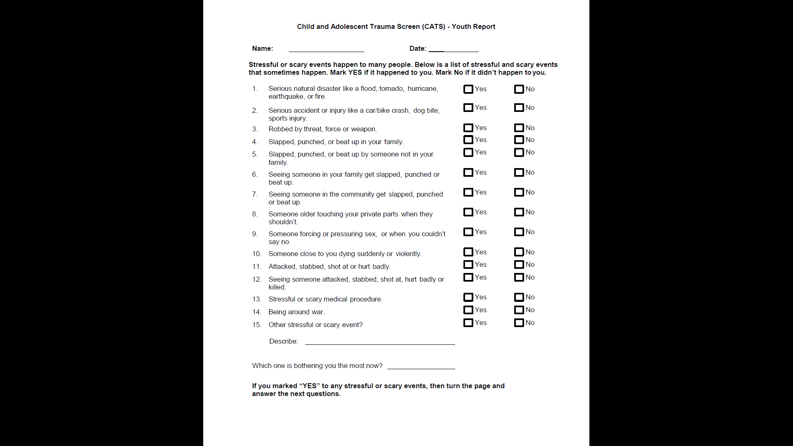
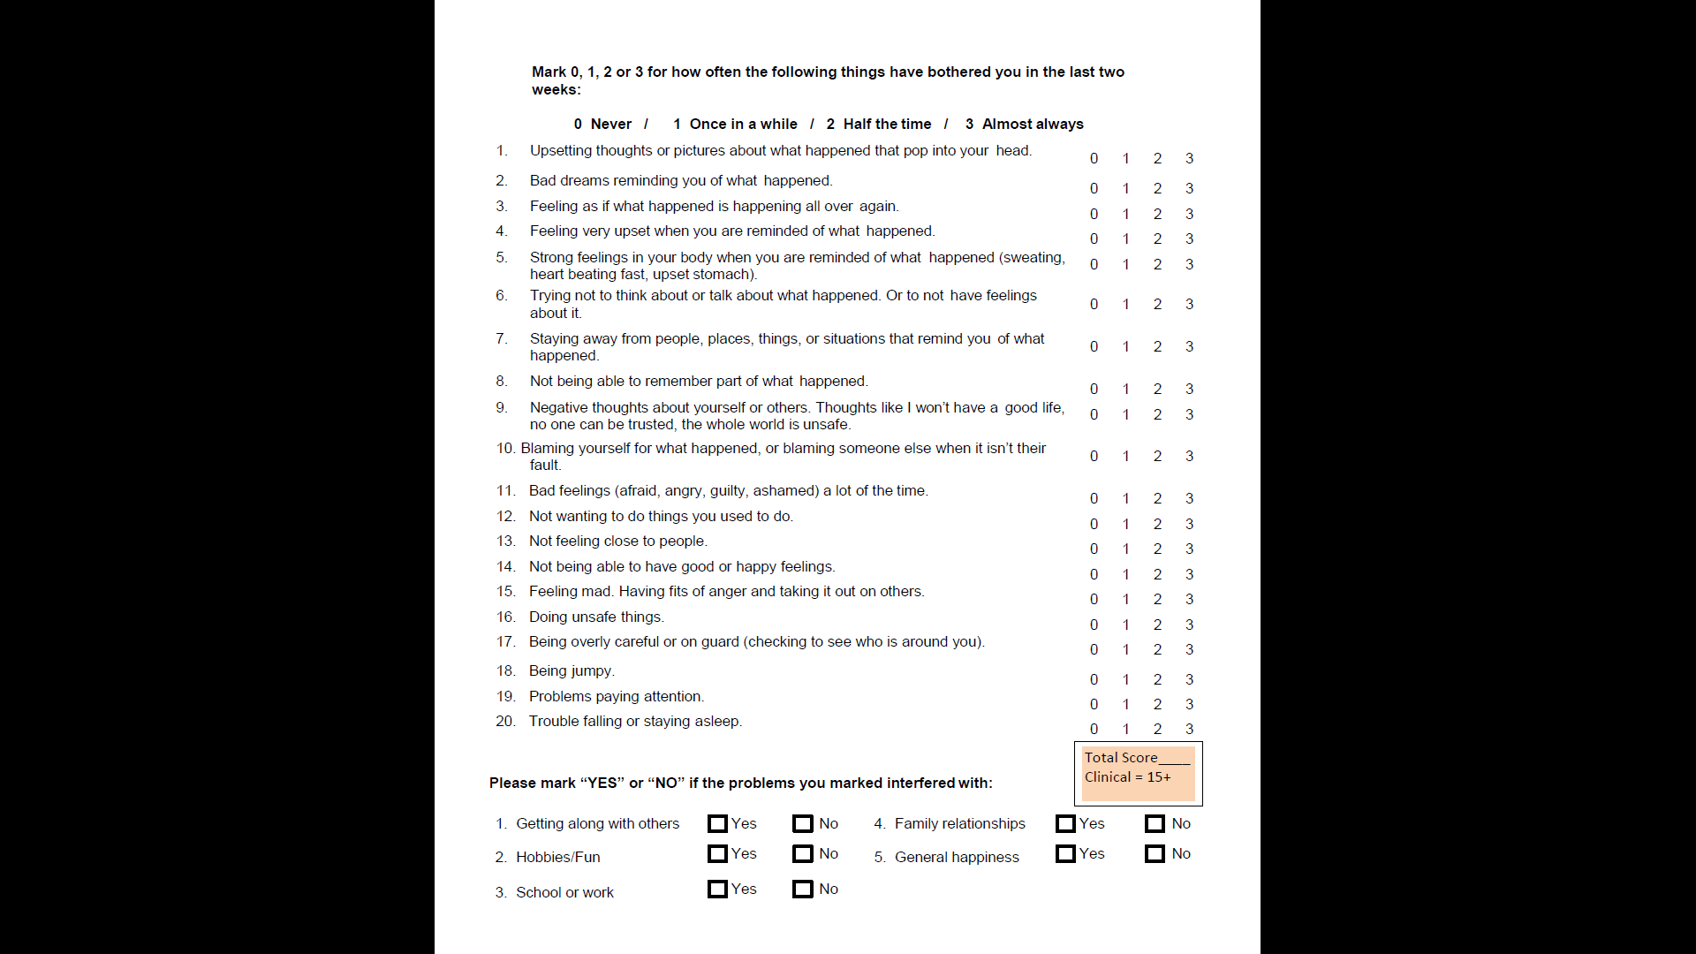

Appendix 4: PTSD Checklist for DSM-5 (PCL-5)- Adults

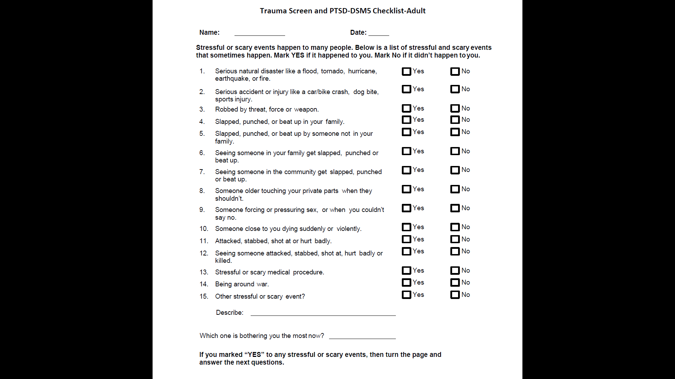
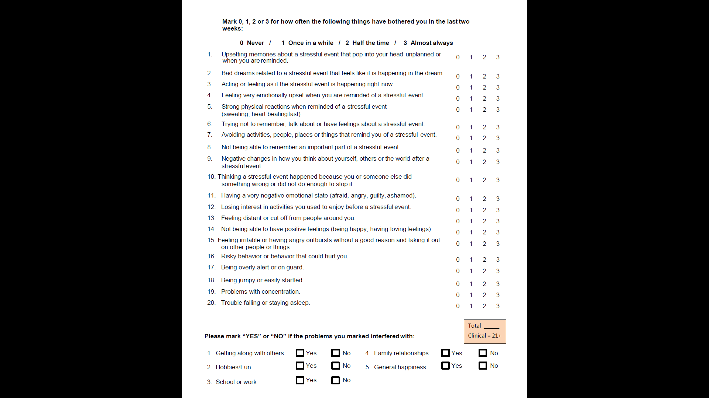

Appendix 5: ASSENT FORM FOR MINORS
To participant,
I, Dr. Wariimi Karingi, a student undertaking a Fellowship in Epidemiology and Biostatistics at the Department of Pediatrics and Child Health, University of Nairobi, request you to participate in a study that I am carrying out at your facility on the prevalence of depression and post-traumatic stress disorder (PTSD) among adolescents attending CCC in hospitals in Ruiru Subcounty.
Purpose of the research study
The purpose of the study is to use validated study tools to determine the prevalence of depression and PTSD among the adolescents aged 10 -19 years on follow up at CCC in hospitals in Ruiru Subcounty.
The process of data collection will involve 3 short questionnaires being administered to you. It will take between 20 to 30 minutes to complete the questionnaires. You will be taken to a quiet room and given a chance to fill out the questionnaire or have it read to you then you pick the suitable responses.
Risks:
There are minimal risks involved in participating in the study: discomfort from some sensitive questions and extra time spent at the hospital during data collection. These will be minimized by ensuring that the questions are asked in a professional manner and delay is minimized during data collection.
Benefits:
The study will not make payments for participating in it. However, the findings of the study will help identify those adolescents who are depressed and having PTSD and refer them for the appropriate management. It will also give information that will be used to show the burden of depression and PTSD and hence recommend to the relevant stakeholders the need of incorporating mental health services as part of routine adolescent health services.
Study participation & Right to Withdraw:
Your participation is voluntary and is appreciated. You are at liberty to terminate your participation any moment with no consequences.
Confidentiality:
The information collected from you for the study will be kept confidential. Your privacy will be observed by issuing you with a study number as identification. No identifiable data will be obtained from you. Your name will not be used on any data collection tools. Data collected will exclusively be used for the study thesis. Hard copies of data will be kept under lock and key, soft data will be stored on a password protected computer.

Investigators Contacts:
You can contact the researcher on Telephone number: 0723847478 or email: wariimi.k@gmail.com
Participant’s statement
I have read and understood the information provided above.
The above details have been read out to me.
All my queries and concerns have been addressed to my satisfaction. I hereby give/decline to give my consent for my child to participate in this study.
Initials of participant: ……………… Study ID number of child ………………
Signature of participant:…………………. Date………………………………….

Researcher’s statement
I, the undersigned, have fully explained the relevant details of this research study to the participant named above and believe that the participant has understood and has knowingly given their consent.
Name of researcher: ………………………… Date: ……………………
Signature …………………………………….

Appendix 6: INFORMED CONSENT FORM
To participant,
I, Dr. Wariimi Karingi, a student undertaking a Fellowship in Epidemiology and Biostatistics at the Department of Pediatrics and Child Health, University of Nairobi, request you participate in a study that I am carrying out at your facility on the prevalence of depression and post-traumatic stress disorder (PTSD) among adolescents attending CCC in hospitals in Ruiru Subcounty.
Purpose of the research study
The purpose of the study is to use validated study tools to determine the prevalence of depression and PTSD among the adolescents aged 10 -19 years on follow up at CCC in hospitals in Ruiru Subcounty.
The process of data collection will involve 3 short questionnaires being administered to you. It will take between 20 to 30 minutes to complete the questionnaires. You will be taken to a quiet room and given a chance to fill out the questionnaire or have it read to you then you pick the suitable responses.
Risks:
There are minimal risks involved in participating in the study: discomfort from some sensitive questions and extra time spent at the hospital during data collection. These will be minimized by ensuring that the questions are asked in a professional manner and delay is minimized during data collection.
Benefits:
The study will not make payments for participating in it. However, the findings of the study will help identify those adolescents who are depressed and having PTSD and refer them for the appropriate management. It will also give information that will be used to show how much of a problem depression and PTSD are and hence recommend to the relevant stakeholders the need of incorporating mental health services as part of routine adolescent health services.
Study participation & Right to Withdraw:
Your participation is voluntary and is appreciated. You are at liberty to terminate your participation any moment with no consequences.
Confidentiality:
The information collected from you for the study will be kept confidential. Your privacy will be observed by issuing you with a study number as identification. No identifiable data will be obtained from you. Your name will not be used on any data collection tools. Data collected will exclusively be used for the study thesis. Hard copies of data will be kept under lock and key, soft data will be stored on a password protected computer.

Investigators Contacts:
You can contact the researcher on Telephone number: 0723847478 or email: wariimi.k@gmail.com
Participant’s statement
I have read out and understood the information provided above.
The above details have been read out to me and I have understood.
All my queries and concerns have been addressed to my satisfaction. I hereby give/decline to give my consent to participate in this study.
Initials of participant: ……………………….
Signature of participant: ……………. Date………………………………….
Researcher’s statement
I, the undersigned, have fully explained the relevant details of this research study to the participant named above and believe that the participant has understood and has knowingly given their consent.
Name of researcher: ………………………… Date: ……………………
Signature …………………………………….

Appendix 6: INFORMED CONSENT FORM FOR PARENTS OF MINORS

To participant,
I, Dr. Wariimi Karingi, a student undertaking a Fellowship in Epidemiology and Biostatistics at the Department of Pediatrics and Child Health, University of Nairobi, request you to allow your child to participate in a study that I am carrying out at your facility on the prevalence of depression and post-traumatic stress disorder (PTSD) among adolescents attending CCC in hospitals in Ruiru Subcounty.
Purpose of the research study
The purpose of the study is to use validated study tools to determine the prevalence of depression and PTSD among the adolescents aged 10 -19 years on follow up at CCC in hospitals in Ruiru Subcounty.
The process of data collection will involve 3 short questionnaires being administered to your child. It will take about 20 -30 minutes to complete the questionnaire. Your child will be taken to a quiet room and given a chance to fill out the questionnaire or have it read to them then they pick the suitable responses.
Risks:
There are minimal risks involved in participating in the study: discomfort from some sensitive questions and extra time spent at the hospital during data collection. These will be minimized by ensuring that the questions are asked in a professional manner and delay is minimized during data collection.

Benefits:
The study will not make payments for participating in it. However, the findings of the study will help identify those adolescents who are depressed and having PTSD and refer them for the appropriate management. It will also give information that will be used to show how much of a problem depression and PTSD are and hence recommend to the relevant stakeholders the need of incorporating mental health services as part of routine adolescent health services.
Study participation & Right to Withdraw:
Your participation is voluntary and is appreciated. You are at liberty to terminate your participation any moment with no consequences.

Confidentiality:
The information collected from you for the study will be kept confidential. Your privacy will be observed by issuing you with a study number as identification. No identifiable data will be obtained from you. Your name will not be used on any data collection tools. Data collected will exclusively be used for the study thesis. Hard copies of data will be kept under lock and key, soft data will be stored on a password protected computer.
Investigators Contacts:
You can contact the researcher on Telephone number: 0723847478 or email: wariimi.k@gmail.com
Participant’s statement
I have read and understood the information provided above.
The above information has been read out to me and I have understood.
All my queries and concerns have been addressed to my satisfaction. I hereby give/decline to give my consent for my child to participate in this study.
Initials of parent: ……………… Study ID number of child………………
Signature of parent: ………………… Date………………………………….
Researcher’s statement
I, the undersigned, have fully explained the relevant details of this research study to the participant named above and believe that the participant has understood and has knowingly given their consent.
Name of researcher: ………………………… Date: ……………………………
Signature …………………………………….

